|  |
| --- |
| Photo displaying partial image of two pie charts on a canvas-textured page |
| Project handbook |
| |  |  |  | | --- | --- | --- | |  |  |  | |

Contents

Introduction 2

Project Specification 2

Use Stories/Cases 3

Agile methodology 4

Mood Board 4

Wireframes 7

Prototypes 10

Database design 11

Website design 12

# Introduction

Welcome to the project handbook for our clothing website. This website has been developed using HTML, CSS, and JavaScript, and features a database spreadsheet that has been normalized to ensure efficient data management. We have also used wireframes to create both a desktop and mobile view and have a mood board to guide the colour scheme of the website. Throughout the development process, we have employed the Agile methodology, which emphasizes flexibility and continuous improvement. This handbook will provide an overview of the project, including its goals, design, and development process, as well as resources and guidelines for ongoing maintenance and improvements.

# Project Specification

**Project Specification**: Bargain Rail (Clothing Website)

Objective: To design and develop an e-business website that allows customers to easily browse and purchase clothing items online.

**Scope**: The website will feature a wide variety of clothing items for men, women, and children, including tops, bottoms, dresses, and outerwear. The website will have a search function, a filter function, and a shopping cart feature. Customers will be able to create accounts, save items to carts, and view their purchase history.

**Deliverables:**

* A fully functional and responsive e-commerce website
* A customer registration and login system
* A shopping cart feature
* A search and filter function
* A customer account management system
* Inventory management (Add/Update/Delete)

**Technologies**: The website will be developed using HTML, CSS, JavaScript. It will be hosted on a server (we have recently started doing servers in our Web Development Applications module) and will use a MySQL for the database.

**Timeline:** The development of the project is expected to take up the full year (2 semesters), with regular check-ins and progress updates with the Scrum Master and Customer

The above project specification gives a brief overview of the objectives, scope, deliverables, technologies and timeline that will be used in the development of a clothing e-commerce website. This specification will serve as a guide for the development team and stakeholders to follow throughout the project's lifecycle.

# Use Stories/Cases

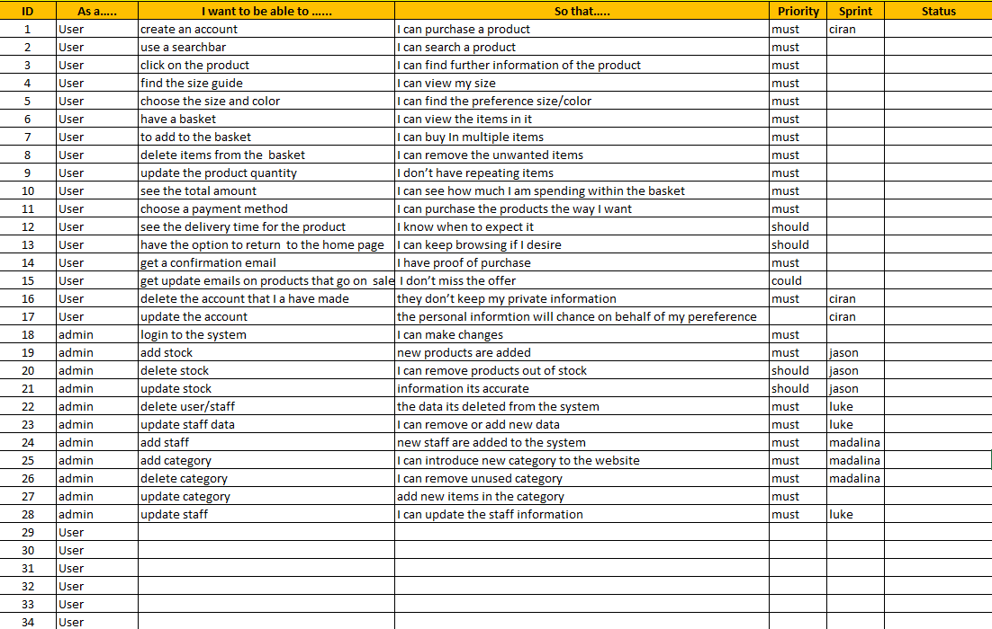

User stories are short, simple descriptions of a feature or functionality that a user wants to see in a product. They are often used in agile software development methodologies as a way to capture requirements and guide the development process. User stories are typically written from the perspective of the end user and focus on the value that a particular feature or functionality will provide.

The main advantage of user stories is that they provide a clear and concise way to capture the user's needs and requirements, making it easier for the development team to understand the user's perspective and build a product that meets those needs. User stories also help to keep the development focused on delivering value to the user and can help to ensure that the final product is more likely to meet the user's needs and be successful.

We set priority, status, sprint and other attributes for each user story to help us manage and track the development process. The priority attribute helped us to identify which user stories were most important to the website's success and therefore needed to be completed first. The status attribute helped us to keep track of the progress of each user story, so we knew which ones were completed, in progress, or still needed to be started. The sprint attribute helped us to organize the user stories into groups of tasks that needed to be completed within a specific timeframe.

By using user stories and setting priority, status, sprint and other attributes, we were able to better manage and track the development process and ensure that the website would meet the needs of its users. This approach helped us to stay focused on the goals of the project and prioritize the features and functionality that were most important to the website's success.

# Agile methodology

Agile methodology is a project management approach that emphasizes flexibility and continuous improvement. It is based on the Agile Manifesto, a set of values and principles for software development that prioritize individuals and interactions, working software, and customer collaboration over processes and tools. Agile methodology is commonly used in software development but can also be applied to other types of projects.

One of the key principles of Agile methodology is to break down a project into small, manageable chunks called sprints. During each sprint, a cross-functional team works together to complete a specific set of tasks, with the goal of delivering a working product increment at the end of each sprint. The team holds daily stand-up meetings, called Scrums, to discuss progress and any obstacles they are facing.

Another important aspect of Agile methodology is the focus on customer collaboration and feedback. The team works closely with the customer or stakeholder to prioritize features and requirements, and regularly gathers feedback on the product as it is being developed. This allows for adjustments to be made throughout the project in order to ensure that the final product meets the customer's needs.

Agile methodology also promotes a culture of continuous improvement. The team regularly reflects on their work and processes and looks for ways to improve efficiency and effectiveness. This can involve experimenting with different tools and techniques and adjusting the team's workflow as needed.

Overall, Agile methodology values flexibility, collaboration, and continuous improvement, and allows teams to deliver high-quality products in a timely and efficient manner.

# Mood Board

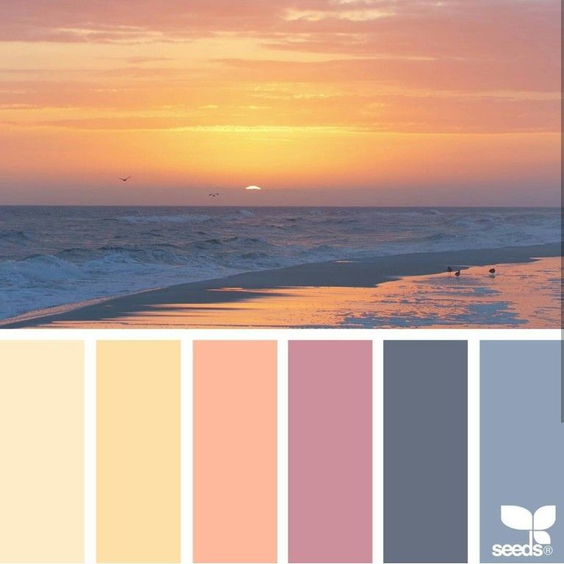

This was our original mood board decision. After about a week or so with this mood board, for our clothing website, we made the decision to not use a Hawaiian themed mood board because I felt it would not be perceived as professional. While the Hawaiian theme may have been visually appealing and on-trend, we ultimately believed it would not align with the overall aesthetic and tone of the website. Instead, we chose to focus on creating a mood board that would represent a more professional and sophisticated look and feel for the website, as it would be more in line with the target audience and the overall brand image. This decision was based on my understanding of the target audience and the need to create a professional image for the website.

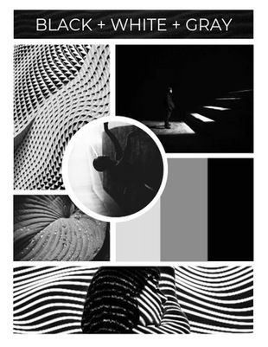

After considering different options, my group ultimately chose to use a black and white themed mood board for our clothing website. This decision was made after we realized that the initial idea of a Hawaiian themed mood board didn't align with the overall aesthetic and tone that we wanted to achieve for the website.

We took into consideration the target audience, and a black and white theme would be more versatile and timeless, it would also allow the clothing pieces to stand out more. We also wanted to create a minimalist look, and a black and white theme would work well for this. By using a black and white mood board, we were able to create a clean, modern look that would appeal to our target audience.

The process of choosing the right mood board wasn't an easy one, but we took time to evaluate different options and make sure that the final choice aligns with our goals and the target audience. Ultimately, our decision to use a black and white themed mood board was the best choice for our website, as it helped to create a professional and sophisticated look and feel.

# Wireframes

Desktop View:

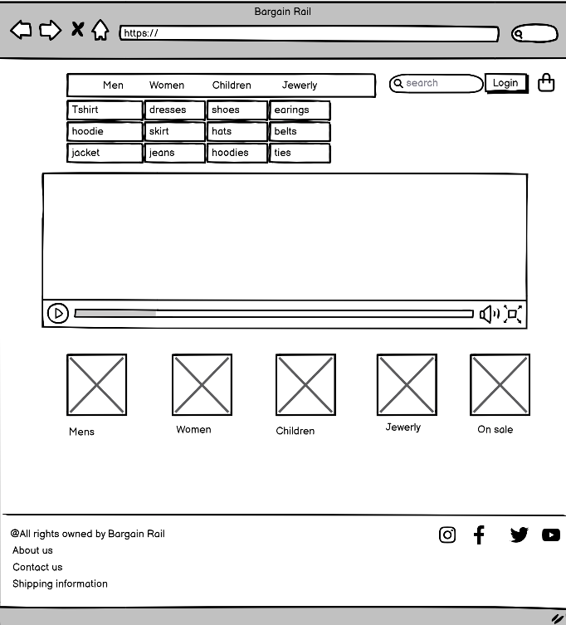

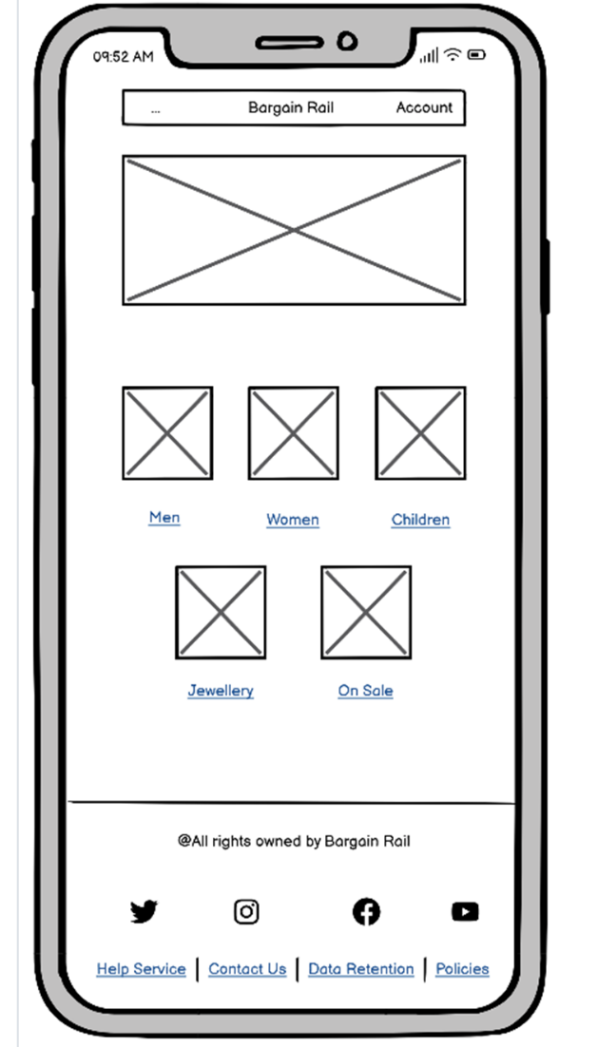 Phone view:

Wireframes are simplified, low-fidelity visual representations of a website or application's layout and structure. They are commonly used in the early stages of website or app design to establish the overall layout and organization of content and functionality, before moving on to more detailed design elements such as color and branding.

Wireframes are an important tool in the web design process as they help to establish the structure and layout of a website or app and allow for easy communication and collaboration between the design team and other stakeholders. They provide a clear visual representation of how the website or app will function, which makes it easy for everyone to understand and provide feedback.

In the design process of our clothing website, we used both desktop and mobile wireframes to get a rough idea of how everything would look and to identify any necessary changes. By creating separate wireframes for desktop and mobile views, we were able to ensure that the website would be optimized for both types of devices.

Creating wireframes for both desktop and mobile views allowed us to identify any issues with layout or functionality that may have been specific to one type of device. It also gave us the opportunity to make adjustments to the layout and design elements to ensure the best user experience for our visitors, regardless of the device they were using.

We took into consideration the way users interact with websites on mobile devices, and how the layout should adapt to smaller screens, and this helped us identify any issues with navigation, layout, and functionality that may have been specific to mobile devices.

By using both desktop and mobile wireframes, we were able to get a rough idea of how everything would look on different devices and make any necessary changes before moving on to more detailed design elements. This helped us to ensure that the final website would be optimized for both types of devices and provide a great user experience.

# Prototypes

Men's page:

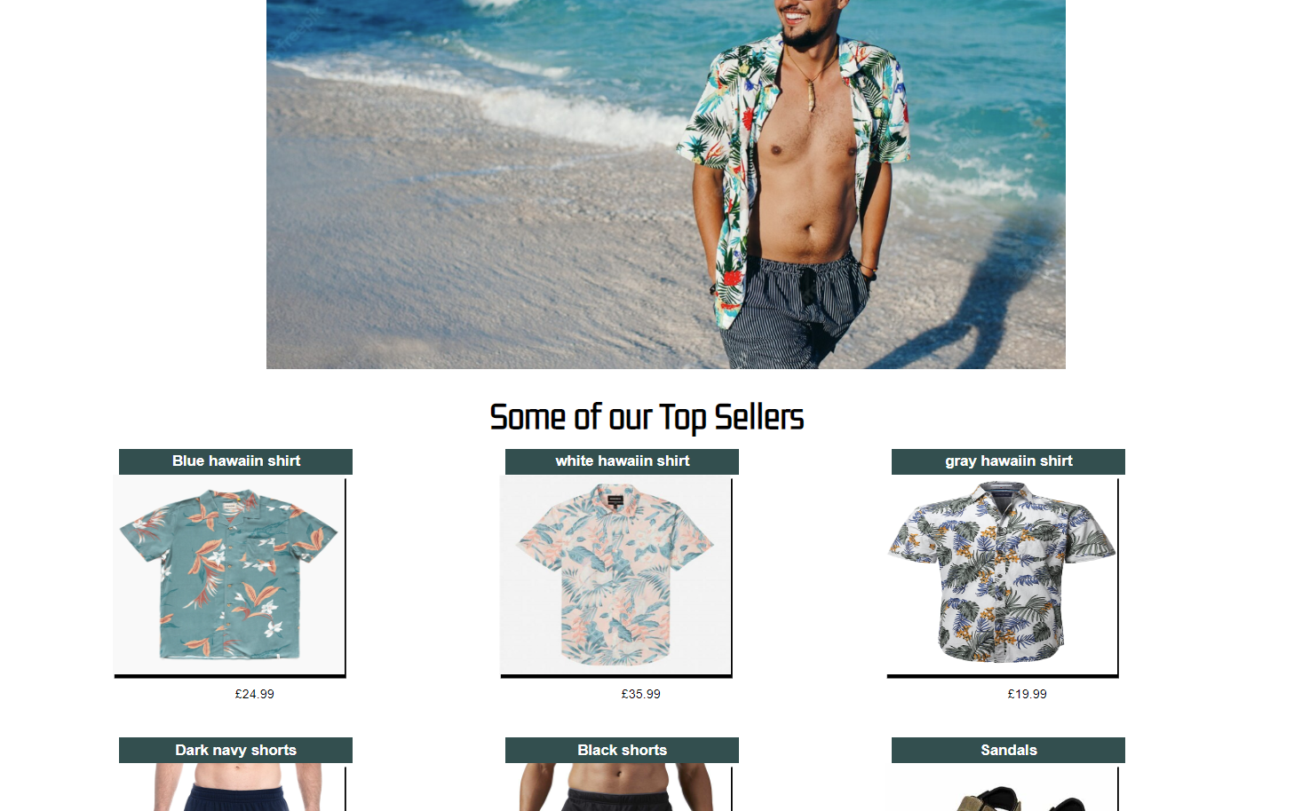

In developing our Bargain Rail website, we created a prototype for the men's page that included a main image and a grid layout design for displaying the clothing items. However, after reviewing the prototype, we decided that the main image did not align with the overall aesthetic of the page and decided to change it. Despite this change, we felt that the grid layout design worked well for displaying the clothing items and decided to keep it as is. We decided to keep a main image for the home/landing page as we felt that was needed and looked great but for the other pages, we decided to stick to a grid layout along with a footer that had animated waves which we used JavaScript for.

As we continued to develop the website, we decided to maintain the same grid layout design for all the pages on the website, except for the home landing page. By keeping the same design style across all the pages, we were able to create a consistent user experience and make it easy for users to navigate the website. The grid layout design was a clear, organized way to present the products, so it was decided to keep that same design style on all other pages. This consistency helped to create a visually cohesive website, making it easy for users to find what they were looking for and increasing the chances of them returning to the site. This also helped to create a brand identity, which was important for the website.

When creating the prototype for our clothing website, we found that it was lacking something that we couldn't quite put our finger on. We realized that the prototype was rough and it did not fully convey the feeling we wanted the website to give to the user. We took a step back and realized that what the website needed was a dedicated product page, where users could easily view and learn more about the products. This led us to come up with the product page, which was designed to showcase the clothing items in a clear and organized way. It included detailed information about the products, such as the materials used, size, and price. It also allowed users to see multiple images of each item.

Incorporating a product page was a crucial step in the development of our website. It allowed us to present the products in a way that was easy for users to understand, and it helped to increase user engagement and sales. The prototype was rough, and it was clear something was missing, but by identifying the problem and coming up with a solution, we were able to create a website that met the needs of its users.

By creating a prototype and testing it, we were able to identify areas that needed improvement and make changes before moving forward with the final design. This allowed us to make sure that the website would meet the needs of its users and provide a visually appealing experience.

# Database design

Spreadsheet:

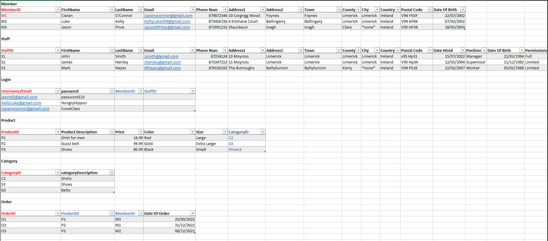

A database spreadsheet is a table that is used to organize and store data in a structured format. It is like a traditional spreadsheet, such as Microsoft Excel or Google Sheets, but with additional functionality for working with and manipulating large amounts of data.

A database spreadsheet typically includes rows and columns, with each row representing a single record and each column representing a field or attribute of that record. Each field or attribute in a database spreadsheet is usually given a specific data type, such as text, number, date, or Boolean, which defines the kind of data that can be stored in that field.

Normalization is the process of organizing data in a relational database to minimize data redundancy and improve data integrity. It involves breaking down a large table into smaller, more manageable tables and establishing relationships between them.

1st Normal Form (1NF): Each table must have a primary key and all data must be atomic (indivisible). This means that each table must have a unique column or set of columns (the primary key) that can be used to identify each row in the table, and that all data in the table must be broken down into the smallest possible pieces, with no repeating groups of data.

2nd Normal Form (2NF): All non-key data must be functionally dependent on the primary key. This means that all data in the table must depend on the primary key and not on any non-key columns.

3rd Normal Form (3NF): All data in the table must not be dependent on any non-key columns. This means that all data in the table must only depend on the primary key and not on any other non-key columns.

In the design of our database spreadsheet, we used Visual Paradigm to link all the tables together. Visual Paradigm is a tool used to create and represent the relationships between different elements in a database. It allows developers to understand how the data is organized and how it is related to other data.

We used Visual Paradigm to create a diagram that linked all the tables in the database spreadsheet together. By representing the relationships between the tables in a visual way, it made it easier for us to understand the structure of the database and identify any potential issues. Visual Paradigm also helped us to identify any missing tables or relationships that needed to be added.

We used Visual Paradigm to create a clear and logical link between all the tables in the database, this helped us to ensure that all the data was properly organized and easy to access. This was especially important since our website was supposed to be able to handle a large amount of data and needed to be efficient.

# Website design

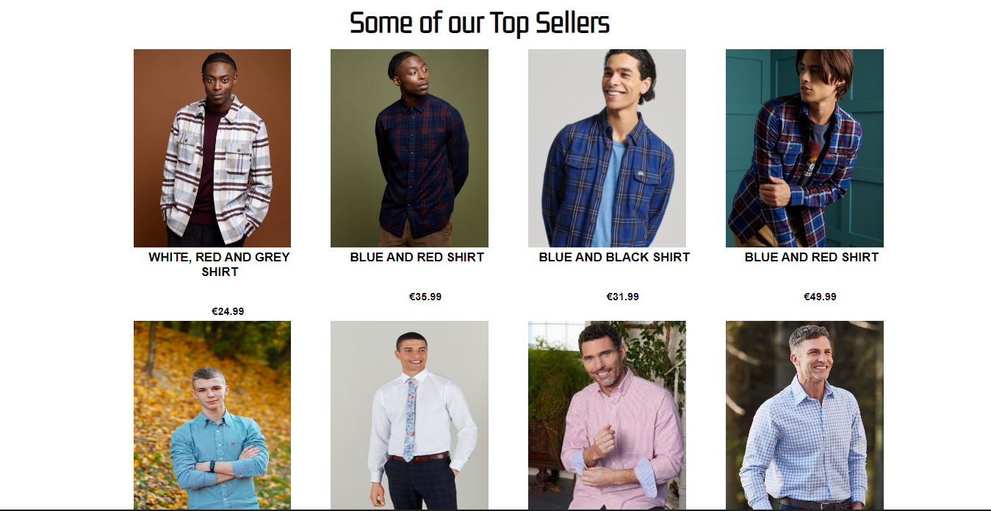

Our current website development is mostly complete, with the home, men's, women's, children's, jewellery, and on sale pages all being completed. The product pages have been designed and implemented, allowing users to easily view and learn more about the products we offer. However, there are still some important tasks that need to be completed before the website can be considered fully finished.

One of the main tasks that still needs to be done is to add at least one product to every page, this will help users to see what types of products we offer and help to increase engagement and sales. This task is important because it will help to fully showcase our products and give users a better understanding of what we have to offer.

Another task that needs to be completed is fixing small bugs that have been identified during development. These bugs include consistency issues, such as the logo of the website changing size on different pages. Fixing these bugs is important because it will help to improve the user experience and make the website more visually appealing.

Lastly, we are working on making sure that the website is consistent throughout all pages, this means checking that the same design and layout is used on all pages, and that the same typography, colors, and other design elements are used consistently. This will help to ensure that the website is visually cohesive and easy to navigate.

Overall, our website development is mostly complete, but there are still some important tasks that need to be completed before the website can be considered fully finished. By working together as a team, we will be able to complete these tasks and launch a polished and professional website that meets the needs of our users.

